**CASE STUDY**

To solve problem live tutoring sessions to students across the world, I prepared a Detailed Design Document.

**Loop holes in Requirement:**

1. Student profile doesn't showcase his existing skills. So tutor can understand the level of student.
2. There is no way to assess the tutor expertise.
3. Tutor geniuses are not ensured in current requirement.
4. There might be possible that student will take the service of tutor and later deny for payment.

**Features and new Idea:**

1. Tutor can upload their video profile. So student can view that and decide which tutor to go with.
2. Tutor can create assignments for Students.
3. Tutor can upload study materials to a marketplace.
4. In feedback apart from just ratting they can provide descriptive feedback.
5. One role we can add named Parents. So they can get direct feedbacks related to students

**App Architecture:** 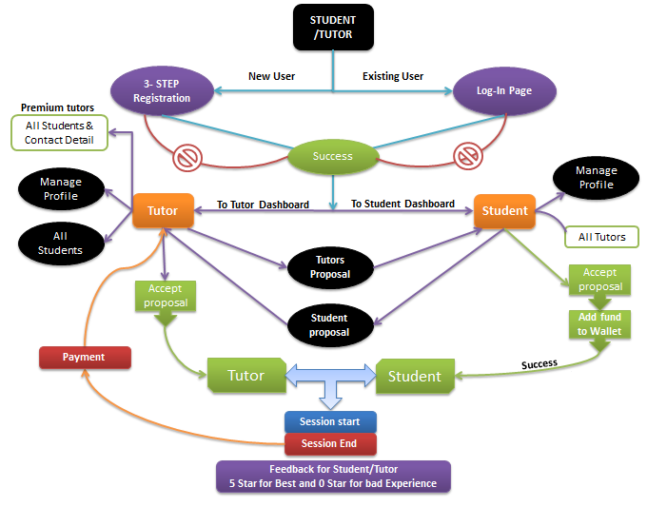

**Database design and Relationship:**

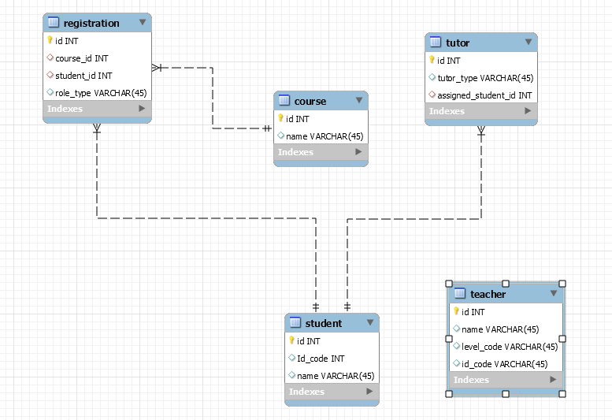

**Infrastructure Requirements:**

1. UI/UX Design: Figma.
2. Frontend: ReactJS
3. Fetch API: AXIOS
4. State management: React-Redux
5. UI frontend design: Bootstrap 5, CSS3, HTML.
6. Frontend Security : Ngnix
7. Backend: .Net
8. REST Api Framework
9. Database: MySQL/MogoDB
10. Payment gets way: Stripe.
11. Domain: Godaddy, cPanel
12. Security: SSL
13. Live Streaming: Socket IO / WebSocket

**Advantages of Technologies:**

1. Figma works on any platform.
2. Figma Sharing Is Uncomplicated and Flexible.
3. Easy to handle large and complex app
4. React provide write less do more.
5. React is supported by multiple developer groups.
6. Multiple npm libraries are available for functionality.
7. Extremely competent.
8. Excellent cross-platform support.
9. Handles dependencies.
10. Template designing made easy.
11. Provides amazing developer tools.
12. UI focused designs.
13. Easy to adopt.
14. Bootstrp5 is latest and help to create responsive website.
15. CSS is beneficial for the entire screen to design and easy and understand and modify.
16. Nginix is most popular to secure frontend.
17. Framework that makes application development a bit easy task for developers.
18. .NET development family of platforms is huge.
19. Rest API Framework is easy to understand and modify.
20. MySQL Database is most popular database. It is very secure and easy to create relationship and make joins.
21. Stripe is a fully secured and safe for payment getway.
22. Godady is good for domain, hosting, professionals email and cPanel.
23. SSL is most secure certificate to secure our website.
24. Live streaming Socket is very flexible and responsive.

**App Overview:**

**Login Page:**

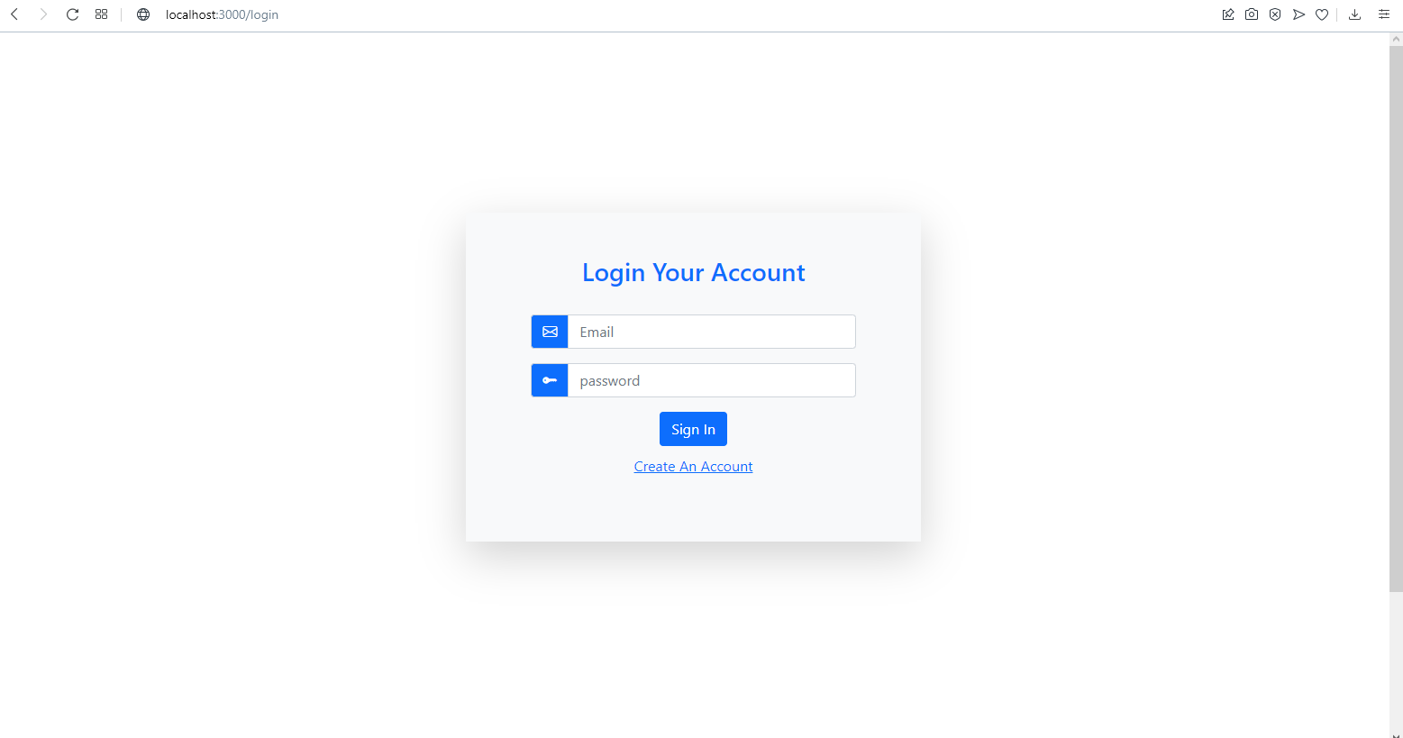

**Registration page:** 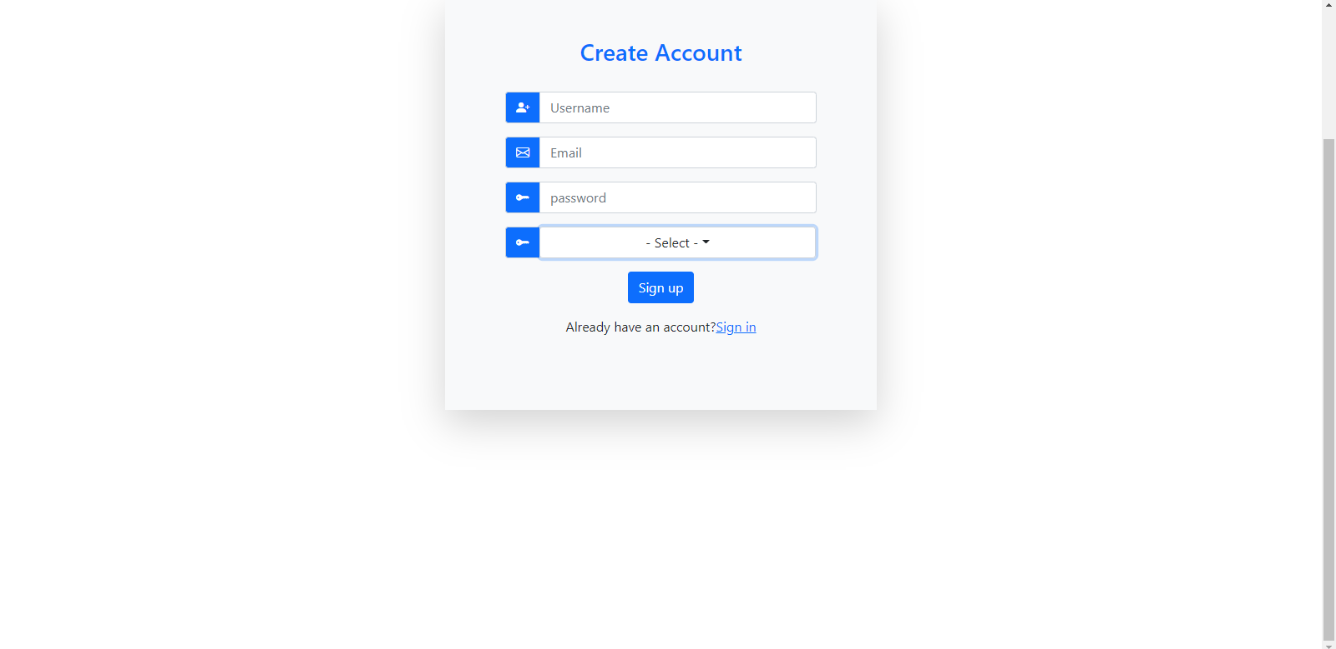

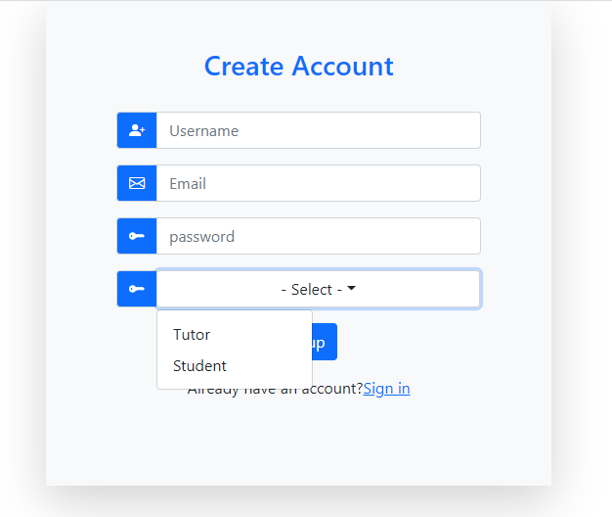

**Tutor Dashboard:**

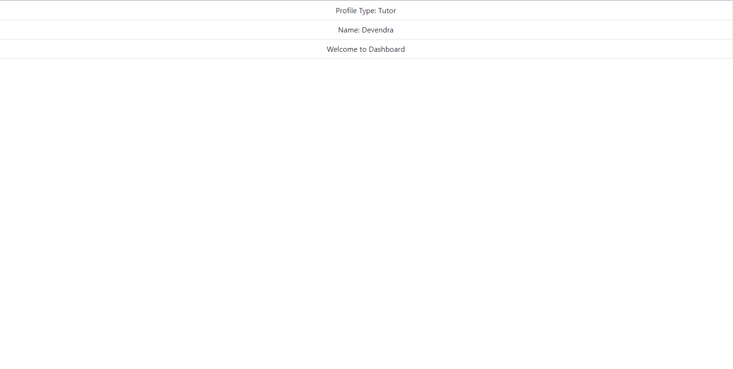

**Student Dashboard:**

